HEY CULLIGAN MAN!

 | I woke up this morning at 5 a.m. with the HEY CULLIGAN MAN! Ad in my brain….and an urgency to retrace Dad’s career timeline and to tell his story.  What makes George Hensler’s life interesting is not simply that he moved from baseball to carpentry to sales. It is that, almost accidentally, his working life crossed several distinctly American chapters of the postwar era—professional baseball, the atomic age, the rise of suburban consumer selling, and finally the great expansion of trucking and interstate commerce.
And I think there is a wonderful parallel with Ray Mazza: Ray Mazza had a small but real hand in bringing America into the computer age. George Hensler had a small but real hand in building America’s atomic age.
Neither man would have described himself that way at the time. They were young Cincinnati men going to work, raising large families and doing what needed to be done.

George Hensler - Timeline
1929 Dad (George Hensler) born Jan 3, 1929
1929 Stock Market Crash October 29, 1929
1930 Living at 2020 Harrison Ave. His dad is Meat Cutter
1938 Living at 2178 Clara Street. His dad is Meat Cutter at 4408 Glenway
1940 Family now owns their own home at 461 Considine Ave
1944 Dad’s brother Paul in WW2 (including Battle of the Bulge at Christmas time)
1946 Dad is 17 years old when his Dad dies of heart attack June 12, 1946.
1948 Dad plays football for 1948 City Champion Price Hill Merchants
1948 and 1950. Dad plays in Baseball Minor League
1949 Navy from Feb 7, 1949 until 20 October, 1949. Baseball for the Navy Blue Jackets
1950 Dad is 21 years old. Living with family at 461 Considine. Playing minor league baseball out in the West.
1951 Dad marries our mom Dorothy Gray on November 22, 1951
Early 1950 Carpenter. One job was carpenter work at Fernald
Early 1950 Selling baby strollers and baby carriages
1957 Mom and Dad buy their first house at 4097 West 8th Street.
1960 Family at 4097 West 8th Street and Dad is Salesman for Culligan Soft Water Co.
1965 House Fire 4097 West 8th Street
1965 Dad is top salesman at Key GMC Truck Sales
1966 Donald Joseph died Dec 23rd
1968 George and Dotty Hensler family at Key GMC Truck Exhibit
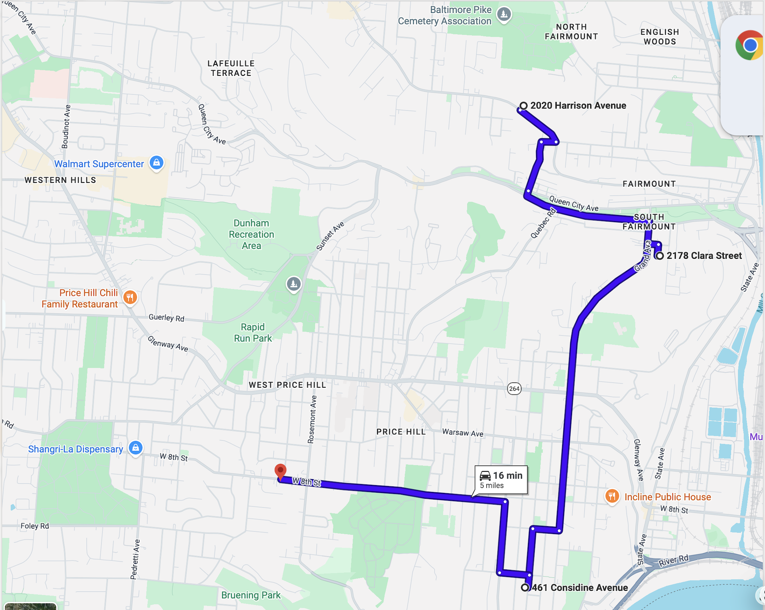
Map above shows the 1930 to 1957 progression from 2020 Harrison (rent) to 2178 Clara (rent) to 461 Considine (own) to 4097 West 8th Street (own). A total distance of 5 miles

George Hensler

Baseball, the Atomic Age, and a Salesman’s Life
George Hensler was born January 3, 1929—less than ten months before the stock market crash that helped usher America into the Great Depression.
His childhood unfolded within a remarkably small part of Cincinnati's West Side. The family moved from a rented home at 2020 Harrison Avenue, to another rental at 2178 Clara Street, and by 1940 George's parents had managed to buy their own home at 461 Considine Avenue. The entire geographic journey covered only about five miles, but it represented something important: a working-class family slowly getting ahead. George's father, George Nelson Hensler, supported the family as a meat cutter, including working at 4408 Glenway Avenue.
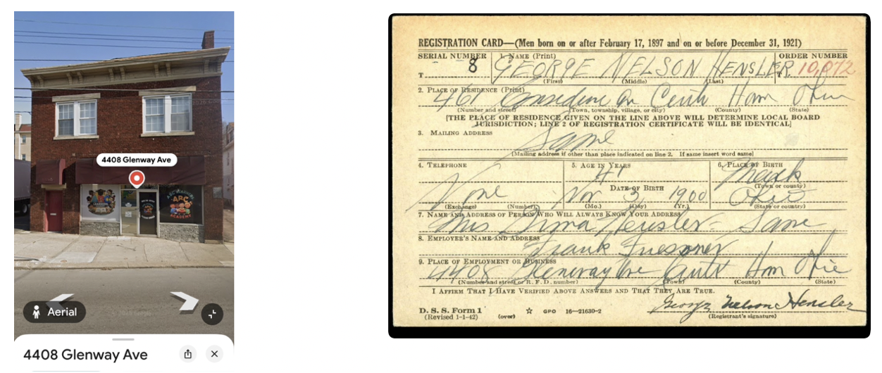
WW2 draft card, Dad’s dad was 41 years old, 461 Considine Ave, Meat Cutter at 4408 Glenway
Then George grew up quickly.
In June 1946, when George was only 17, his father died suddenly of a heart attack. His older brother Paul had only recently lived through World War II, including the Battle of the Bulge. George was coming of age in that strange moment when one enormous chapter in American history had just ended and another was beginning.

The Athlete
Sports were a defining part of George's young life. In 1948, he played football for the Price Hill Merchants, Cincinnati city champions. Baseball, however, appears to have been his real gift.
He played minor-league baseball in 1948 and 1950.
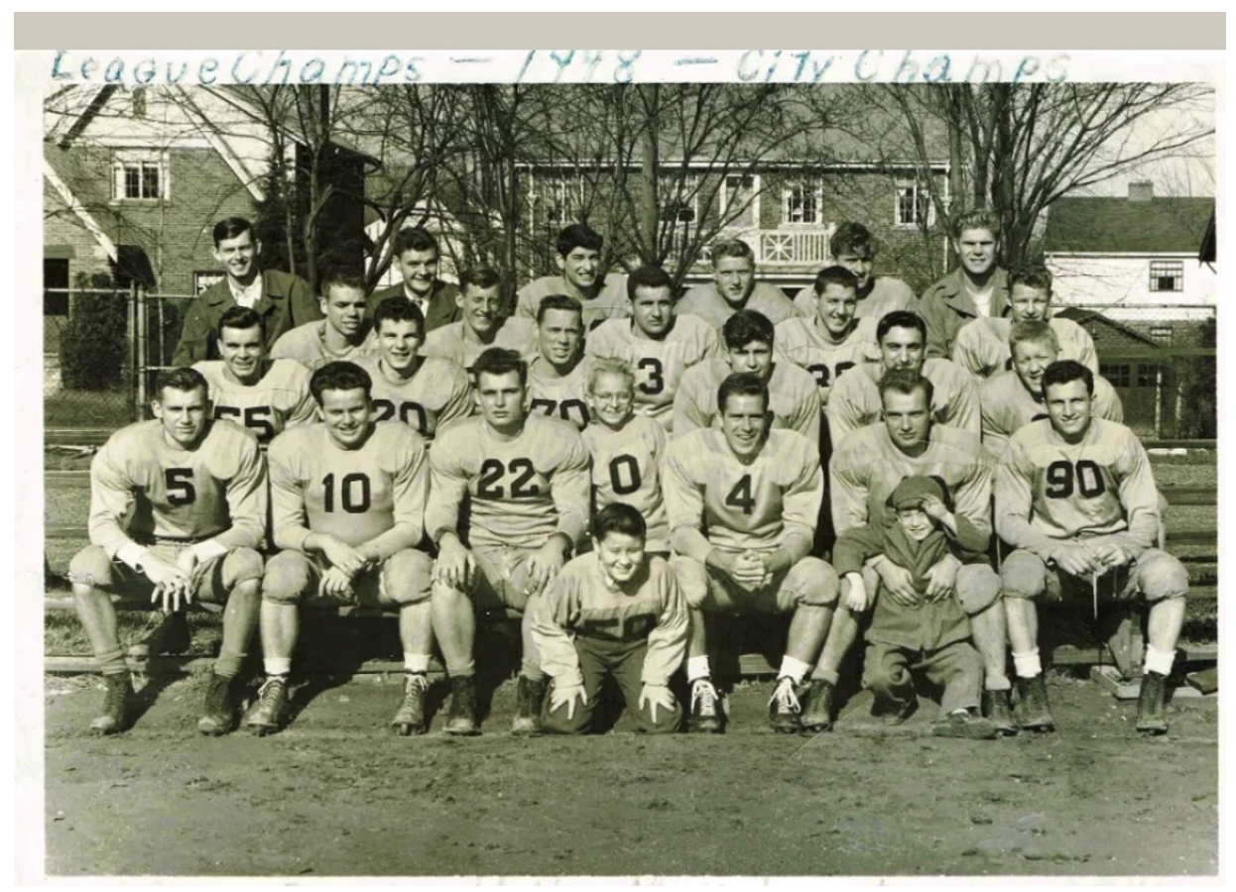
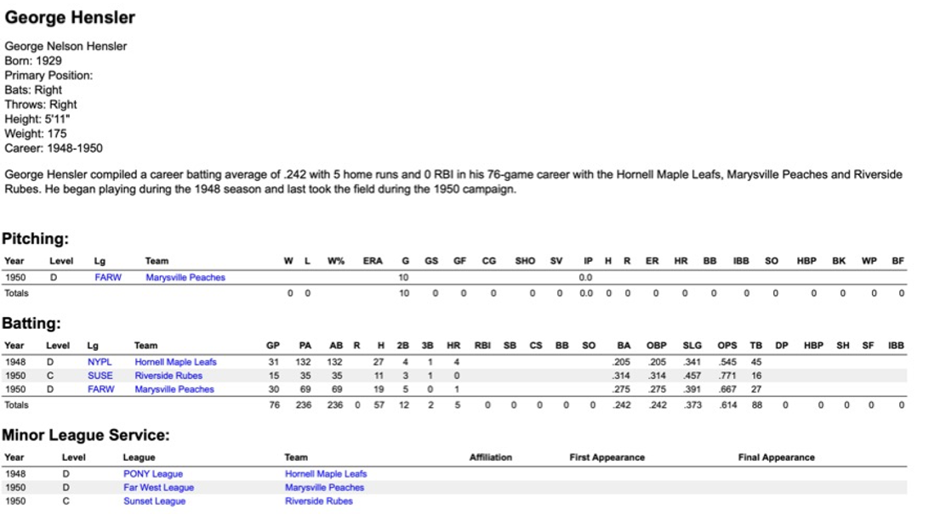
In between came an unusual eight-month chapter. On February 7, 1949, George entered the Navy. Even there, baseball followed him: he played for the Navy Blue Jackets. He left the Navy that October and by 1950, at 21, was back living on Considine Avenue while playing minor-league baseball in the West.
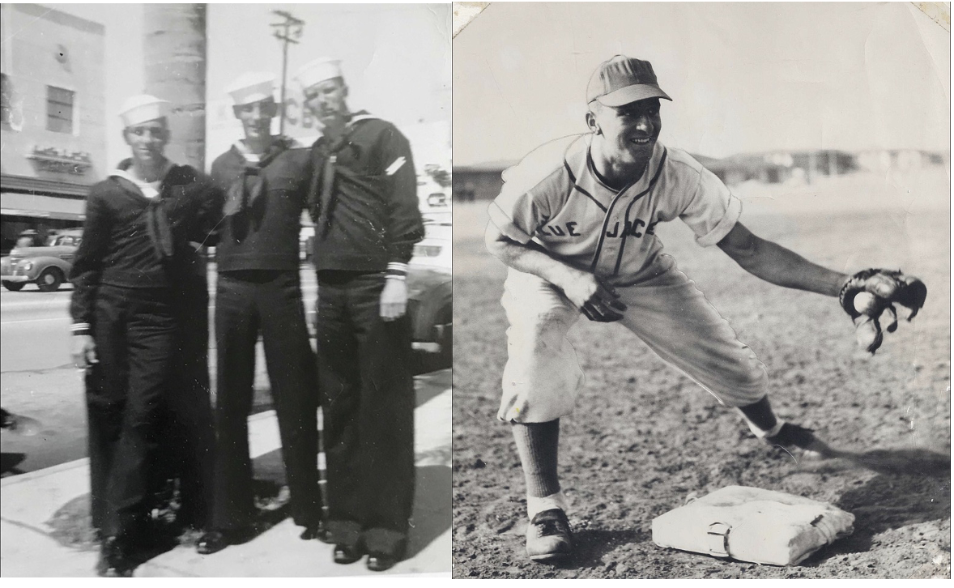
The newspaper clippings from the mid 1950’s show that baseball wasn't simply something George remembered himself as being good at. The newspapers documented it.
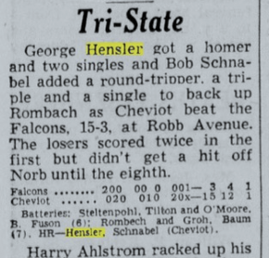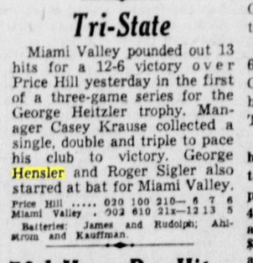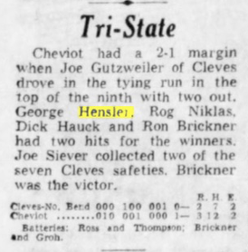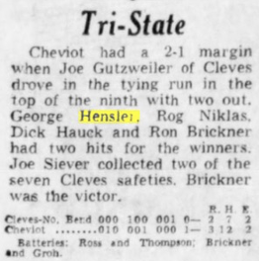
But George's life was about to become much bigger than baseball.
On November 22, 1951, he married Dorothy "Dotty" Gray.
The ballplayer now had a family to build.

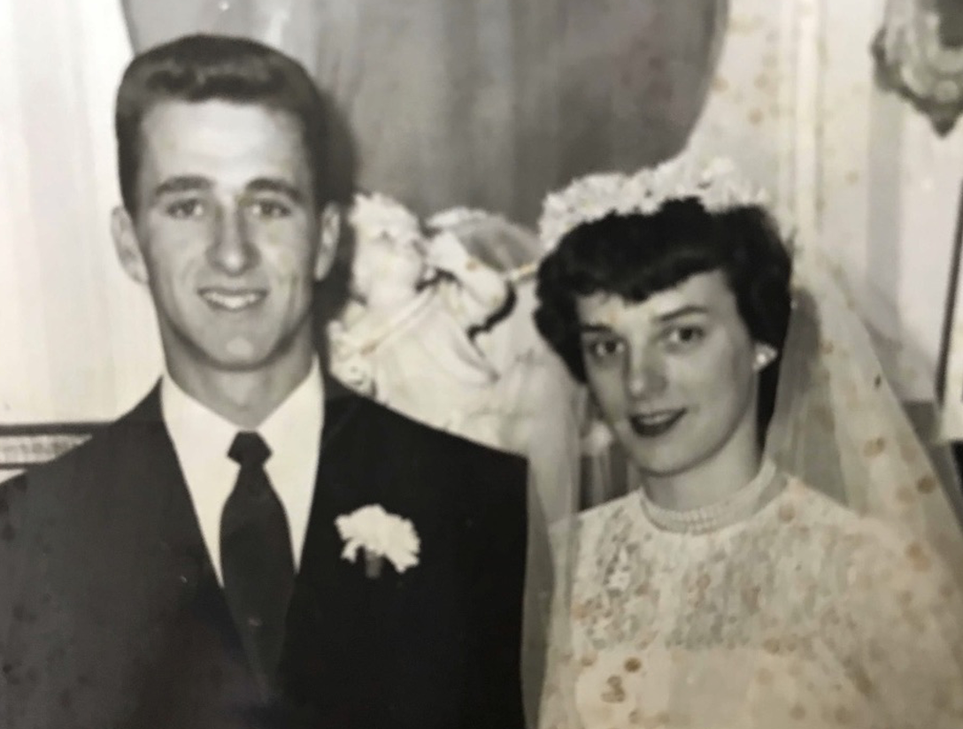

George Hensler and the Atomic Age
This may be the most historically surprising part of his story. After minor-league baseball, George became a carpenter. He continued playing baseball around Cincinnati, including games at Cheviot Field House, but carpentry was now how he made his living. And one of the places where the young carpenter went to work was the construction of the Fernald Uranium Processing plant.
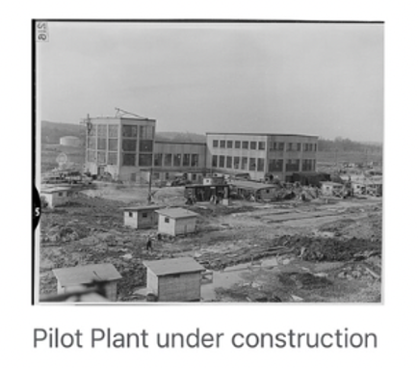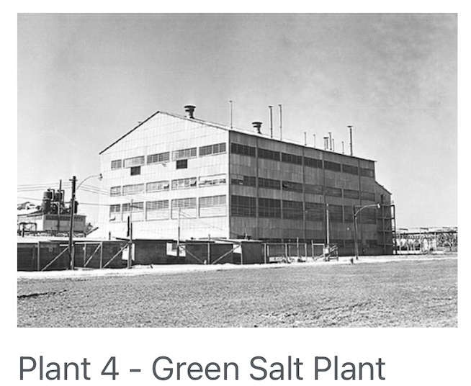
The 31 March 1951 Cin Times-Star announced plans to build a $3 million uranium refining plant at Fernald.
That one sentence deserves to be pulled out of the family story and placed into the larger history of America. George wasn't a nuclear physicist. He wasn't designing an atomic bomb. He wasn't sitting in Washington deciding America's Cold War strategy.
He was a carpenter. But somebody had to build the places where America's atomic program actually happened. Fernald became part of the enormous industrial infrastructure created by the United States during the early Cold War. Fernald operated from 1951 to 1989, converting uranium ore into metal and fabricating that metal into target elements for nuclear reactors.
And there was 22-year-old George Hensler, newly married, helping construct it. That is George's little-known touch on the atomic age. There is something particularly compelling about that because he probably did not think of it as history.
It was a job.
Just as Ray Mazza probably didn't walk into Western & Southern every morning thinking, I'm participating in the beginning of the computer revolution, George probably didn't put on his work clothes and think, I'm helping build America's nuclear infrastructure.
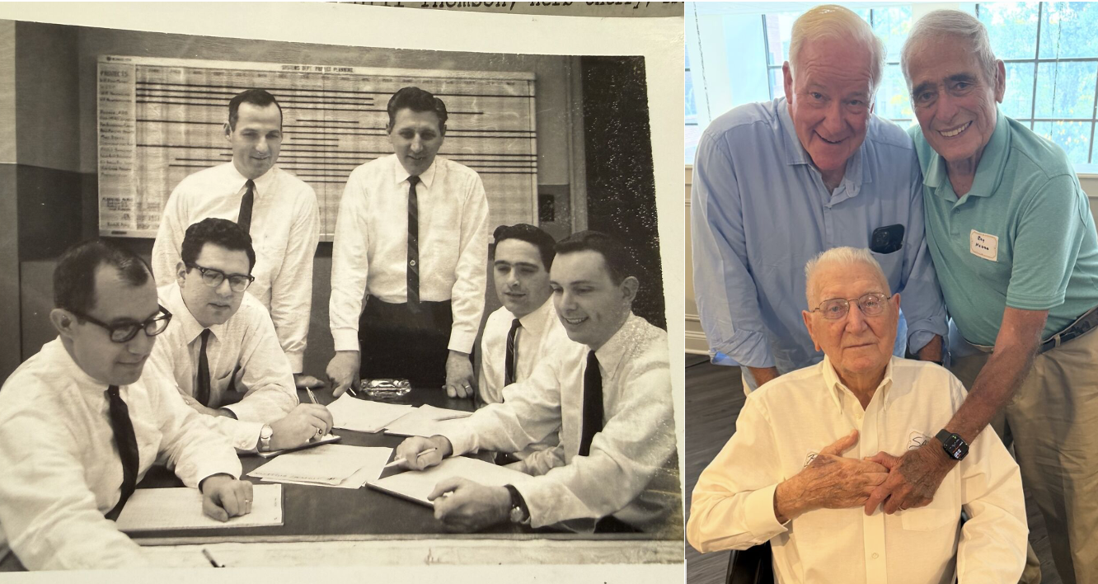
Ray Mazza and team launching the first computer system at Western & Southern (April 1963)

They went to work.
History happened around them.

From Carpenter to Salesman
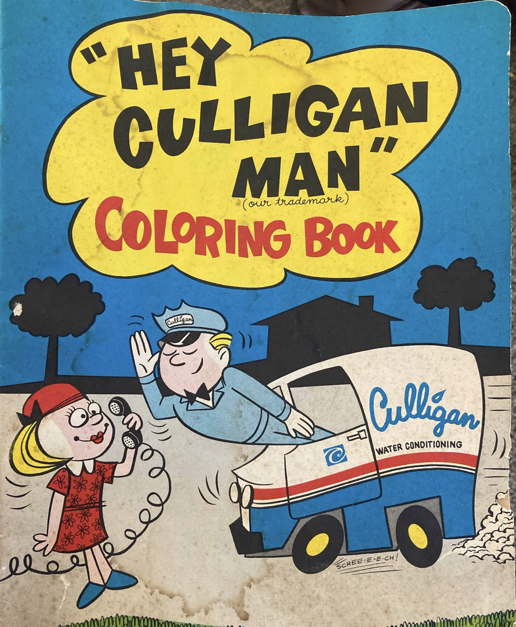 | Eventually George's own body forced the next turn in his life.  Years of baseball and outdoor construction work created a serious problem because of his lupus-related sensitivity to sunlight. Remaining a carpenter was becoming increasingly difficult. So, George did what he seems to have done repeatedly throughout his life:  He adapted.  The carpenter became a salesman…… and a remarkably good one.  His first products were about as far removed from uranium processing as imaginable: baby strollers and carriages. Then came water softeners.  And maybe that is why I woke up today at 5:00 a.m. with "HEY CULLIGAN MAN!" bouncing around in my brain with an urgency to lay out this timeline.
By 1960, George and Dotty were living with their growing family at the home they had purchased in 1957 at 4097 West Eighth Street, and George was a salesman for Culligan Soft Water Company.
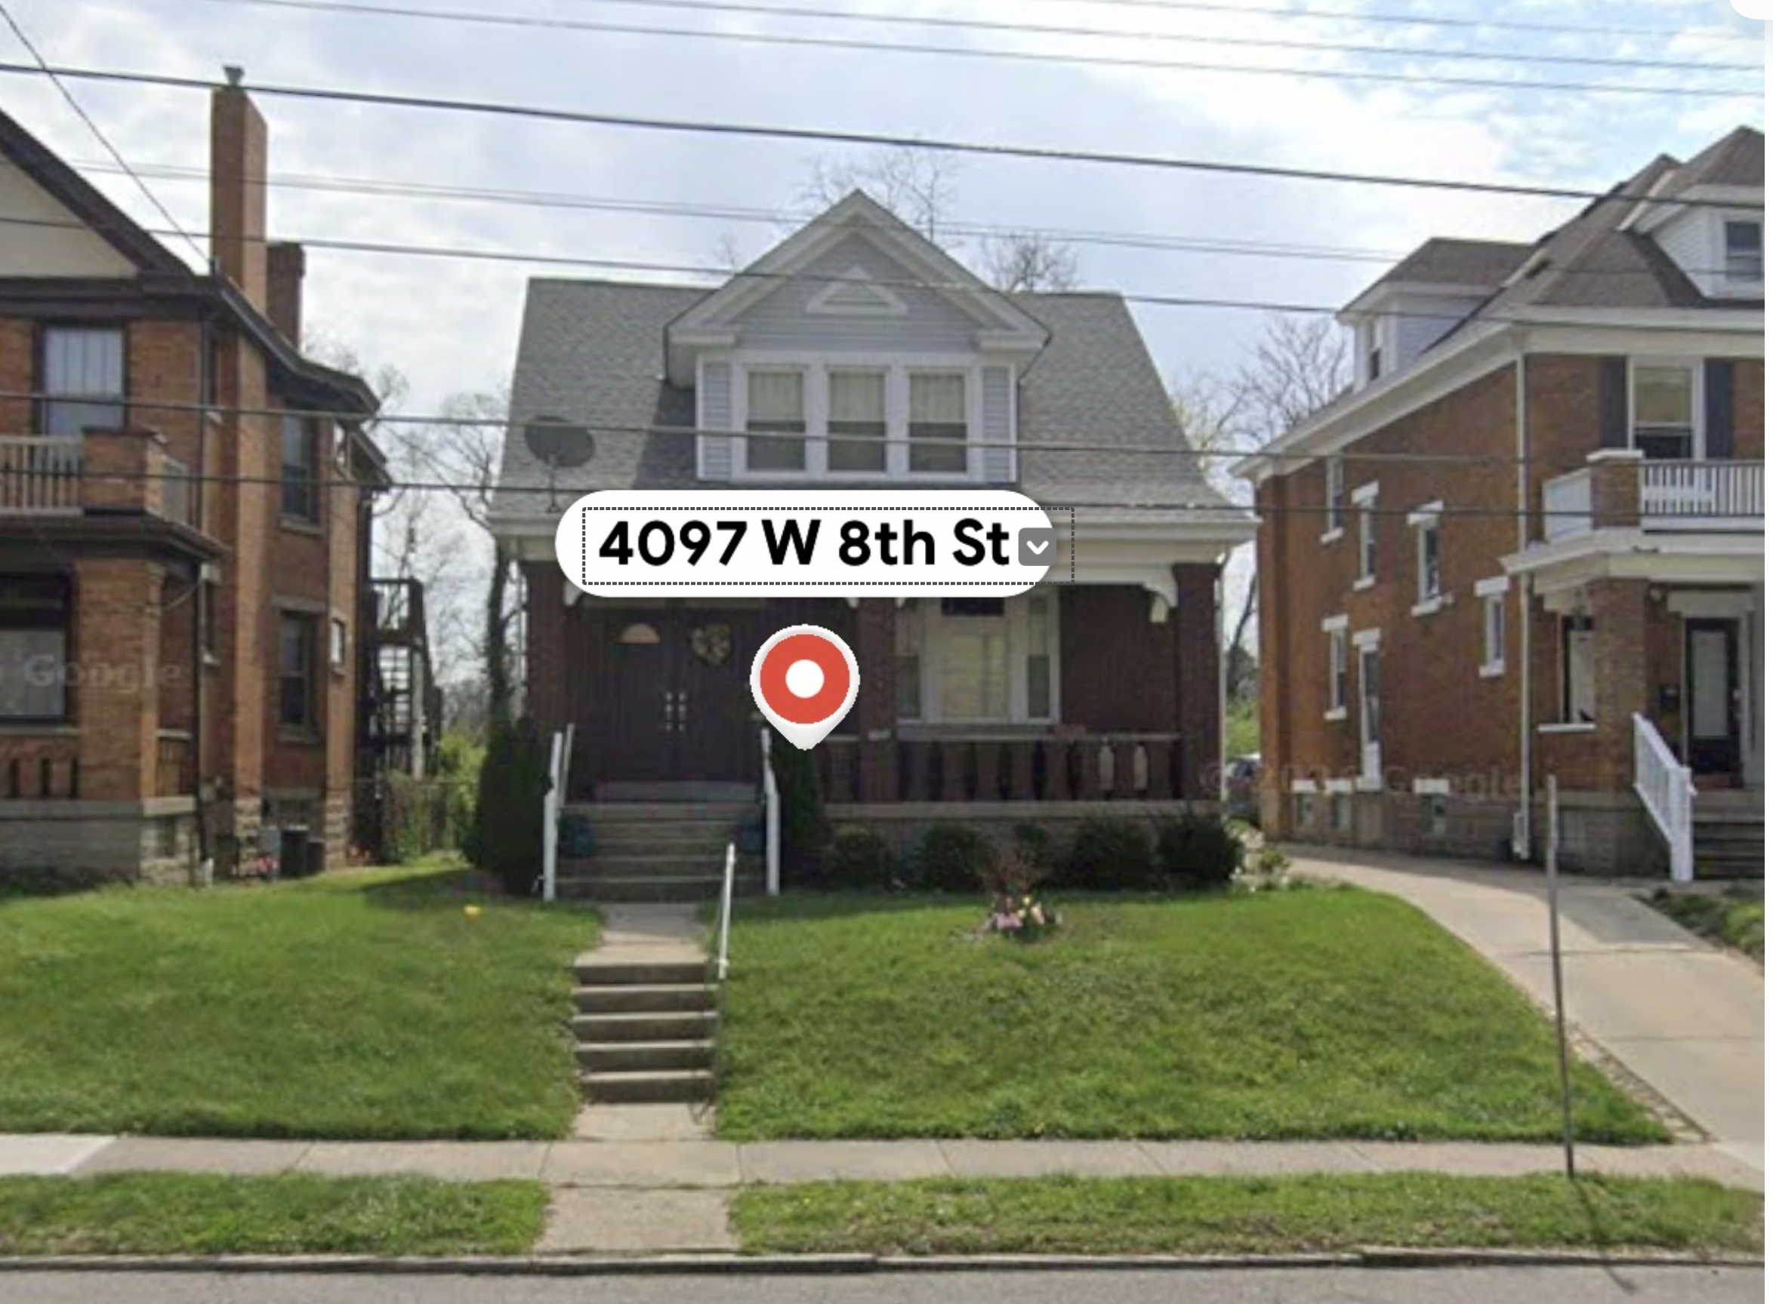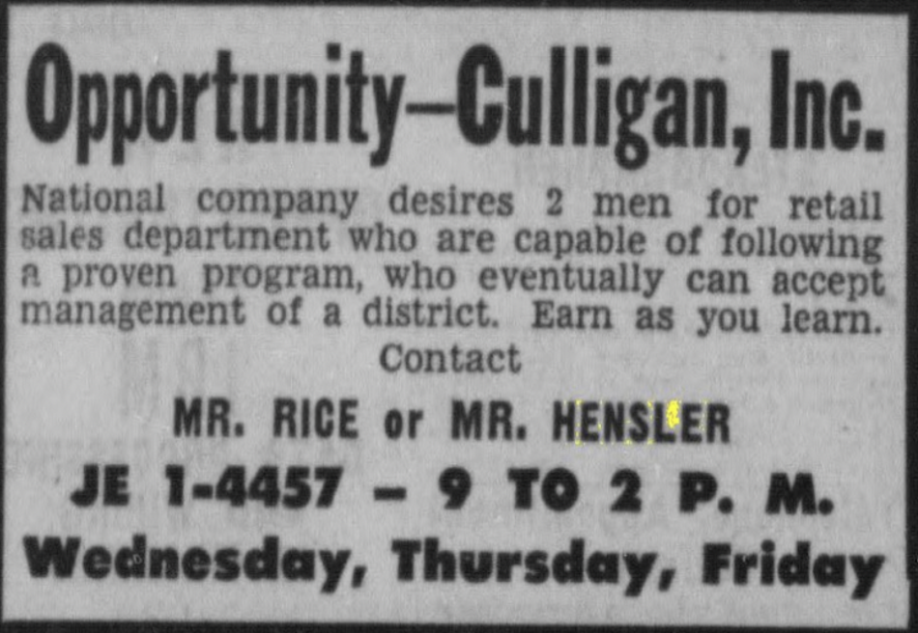
But the newspaper advertisements tell us considerably more than simply where he worked. It suggests George had already progressed beyond simply knocking on doors selling water softeners. He was involved in recruiting salespeople for the organization. George hadn't merely discovered that he could sell. He had discovered that he could build and lead sales organizations. He seemed to have found his professional home.

Trucks
By 1965 George was selling trucks for Key GMC Truck Sales.
And once again, the newspaper record tells us how good he was. 1965 and 1966 clippings show he had been awarded charter memberships in the National GMC Professional Salesmen's Club for outstanding sales work.
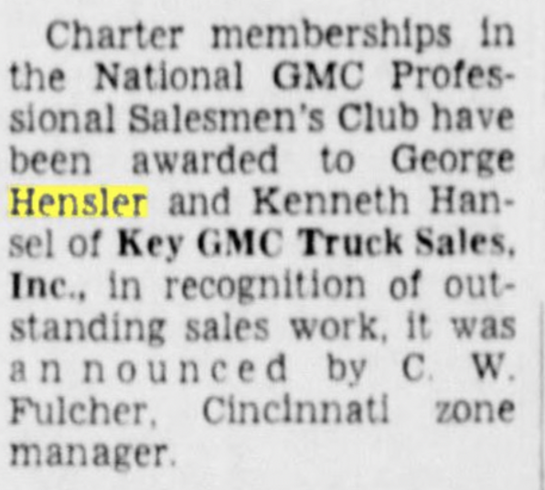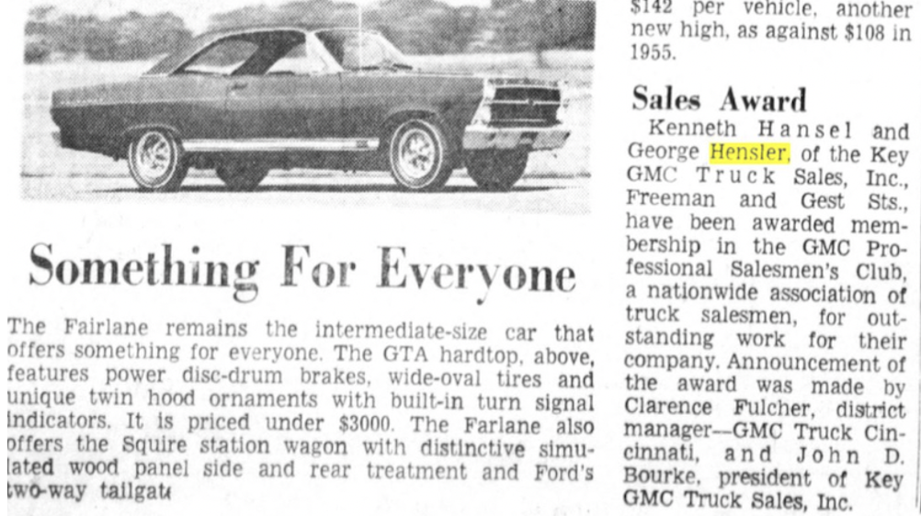

Eleven Children
Behind every one of those career changes was a growing family.
George and Dotty were not building a career in the modern sense of carefully planning the next rung on a corporate ladder.
They were building a life.
Eventually there would be eleven children.
That makes the progression shown in the earlier map particularly meaningful. The map isn't merely a map of Cincinnati addresses. It is a map of aspiration. George began life in rented houses. His father cut meat for a living. His father died when George was seventeen. George tried professional baseball. He served briefly in the Navy. He swung a hammer. He helped build a uranium-processing plant. When illness made outdoor work difficult, he reinvented himself as a salesman.
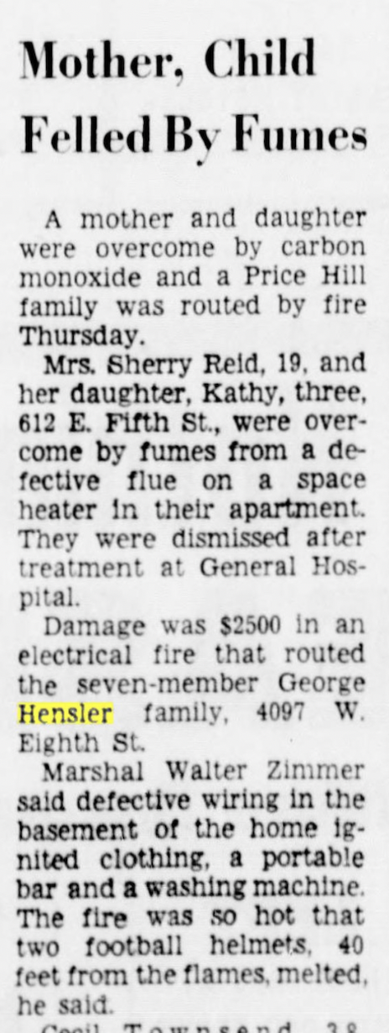 | Then he became exceptionally good at it.  In 1957, George and Dotty bought 4097 West Eighth Street.  Eight years later, that house caught fire.  The January 15, 1965 newspaper clipping described an electrical fire that routed the George Hensler family from the house. For the next three or four months, the family squeezed into Grandma Gray's two-bedroom home on Whitmore Drive—a period remembered in the family, wonderfully, not primarily as a disaster but as:  "What a fun party."  That little sentence may tell us as much about the family as anything in the document.  And the family kept growing.  The photograph on page 20 is extraordinary when viewed in this context. George and Dotty stand surrounded by their children at the 1968 Key GMC Truck exhibit. It visually joins the two great responsibilities of George's adult life:  the family he was raising and the career that paid for it.

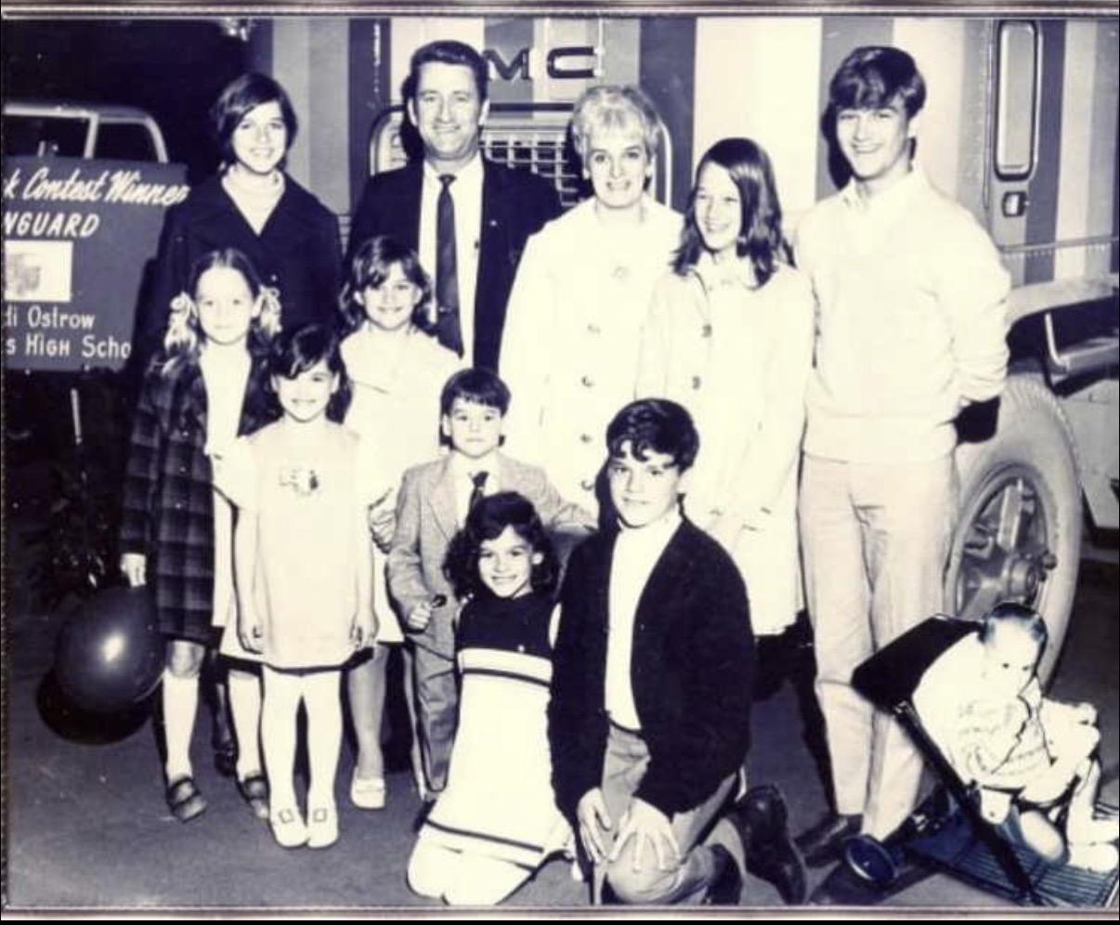

Two Fathers, Two Revolutions
And this is where I would connect George's story with the Ray Mazza story.
They were very different men with very different careers.
Yet both men brushed against enormous technological changes that were transforming America.
Ray Mazza's world was information. On May 22, 1963, Ray and the Western & Southern team helped move an insurance company from paper-based record keeping into electronic data processing. His career intersected with the beginning of the computer age.
George Hensler's world was physical. A decade earlier, as a young carpenter, he helped construct Fernald, part of the massive industrial system America was building to support its nuclear program.
One helped build the infrastructure of the Atomic Age.
The other helped introduce the infrastructure of the Computer Age.
Yet I suspect neither man would have put those accomplishments first when describing his life.
George probably would have talked about baseball.
Or selling trucks.
Or Dotty.
Or the kids.
And perhaps that is the more important story.

George Hensler's Real Legacy
The final newspaper clipping in the PDF, published after George's death, has a wonderful headline:

"George Hensler, 61, Mack — Ex-ballplayer had wonderful experiences during last years"
It remembered the Brooklyn Dodgers minor-league systems. It remembered his sales career with Key GMC and later Peterbilt. It remembered the athlete who eventually became a coach. Most importantly, it surrounded those accomplishments with the names of his wife, children and family.
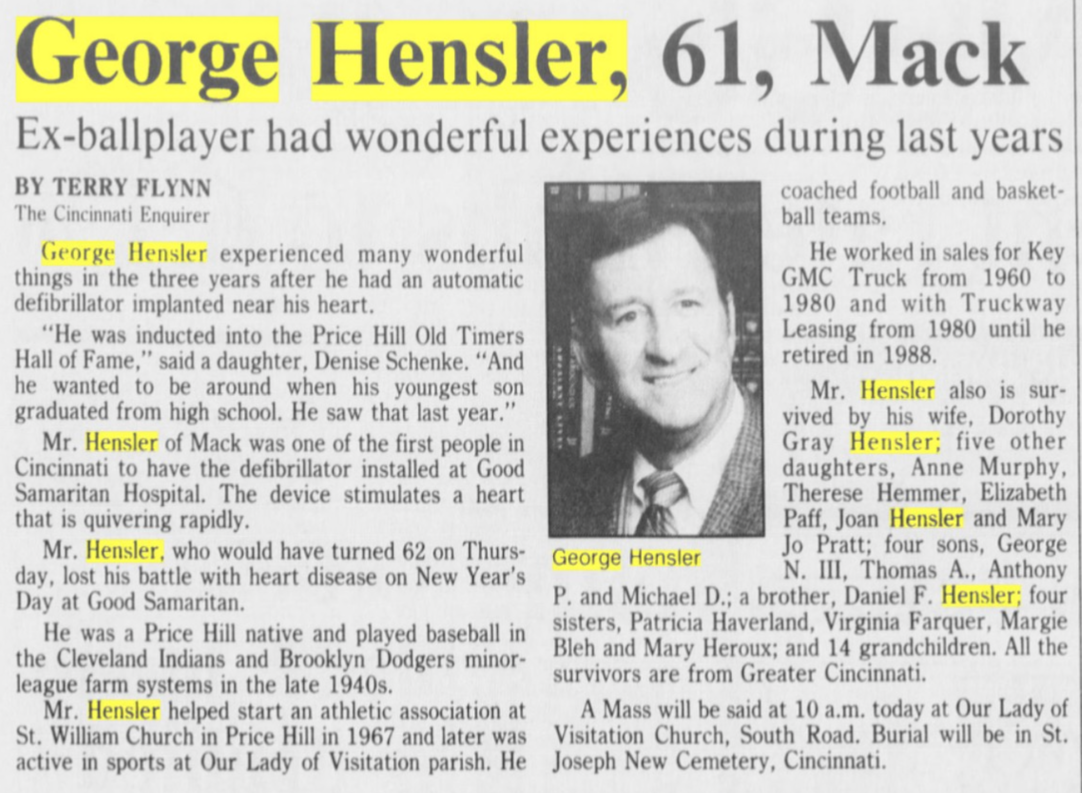
But with the benefit of looking backward across nearly a century, we can see something the obituary could not fully capture.
George Hensler's life traced the arc of a generation.
He was born with the Great Depression approaching.
His brother went off to World War II.
His father died when George was seventeen.
George played baseball when professional baseball still seemed connected to every neighborhood sandlot in America.
He joined the Navy.
He played minor-league ball.
He married his girl.
He became a carpenter.
And for a short period, his hammer helped build one of the places that would make America's nuclear age possible.
Then life changed.
So George changed with it.
He sold baby carriages.
He became the Culligan Man.
He recruited other salesmen.
He moved into trucks.
He became one of GMC's recognized top salesmen.
And through all of it, George and Dotty raised an enormous family. That may ultimately be why the old Culligan advertisement matters. At five o'clock in the morning, "HEY CULLIGAN MAN!" sounds like a funny piece of 1950s advertising nostalgia. But once you put it into the timeline, it becomes something else.
It represents the moment when a young man who had already been a ballplayer, sailor, carpenter and participant in America's emerging atomic industry discovered the talent that would allow him to support his family for the rest of his working life. George Hensler could sell.
And perhaps the common thread through baseball, carpentry and sales wasn't really occupation at all. It was competitiveness. George wanted to win. First there was a scoreboard. Then there was a construction job to finish. Then there was a sales quota.
And eventually there were eleven children depending upon him.
That was the biggest game George Hensler ever played.
And judging from the family photograph at the GMC exhibit in 1968, he was doing pretty well.

